Improvements for V0.2 of the Rastaban PCB

1. VCC pin on the drv8838 driver must be connected to 3.3V or 5.0V for it to work.
2. Try to draw high power traces away from signal traces (move connectors?)
3. For the 2209 we could use UART port, so we can control clock, microstepping etc, set parameters, delays, coolstepping, etc.
4. Buy the right parts 10uf 50V not 10uf 10V
5. FB1 will not work (made for 150mah) remove the inductor.
6. Order a lot of Phoenix ptsm connectors (both receptacle and plug)
7. Remove or find smd variants for fuses (remove some fuses/change values?)
8. Bypass backpower protection circuit (jumper)
9. Raspberry pi remove many caps that are not necessary. Leave c11 and c8, c5 could be 22uf.
10. buildin esd for gpio. Raspberry pi is connected to ground via power connector. Leave ESD footprints, but don’t solder them.
11. Simplify (or maybe even remove) raspberry pi power circuit.
12. Change inductor for rt7272A boost/buck circuit. Chip gets HOT, possibly switch to buck boost converter or worse case: external PSU for rpi (micro usb)?
13. Use a 40 pin **FEMALE** header on the pcb
14. Schematic more readable, don’t run wires through each other
15. Fix u7 (footprint is wrong, partly flipped)
16. Flat cable for 40 pin to 40 pin connection for easier, safer?, testing.
17. Better diode polarity indication on silkscreen
18. **CHECK THE ORIENTATION OF THE RASPBERRY PI HEADER (next time, dubbel dubbel check)**
19. J12 silkscreen error ic and fet are flipped
20. Possibly add pinout (names) to bottom of HAT
21. ENABLE focus must be using a hierarchal flag! Now it’s global, it’s not consistent.
22. All stepper motors work fine with 12V, they have more than enough torque even while using 16bit microstepping. Remove the 24V buck boost converter.
23. Peltier module has not been tested (0.2 sense resistor not received)
24. Micled IC not tested (ic BCR420UW6-7 not received)
25. I2c hat functionality (special eeprom) not tested.
26. 5.0V for mic led not tested. 3.3V from u2 (tlv1117-33) works fine.
27. ESD protection not tested.
28. Maybe use the xl6009 for the raspberry pi and 5V line (4A is possibly more stable than the 3A) or copy a known design ([df robot?](https://www.tinytronics.nl/shop/en/power/voltage-converters/buck-(step-down)-converters/dfrobot-dc-dc-buck-converter-7-24v-to-5v-4a) )
29. Remove some testpoints?
30. I2C NOT working probably due to esd protection ic. Use diode alternative: 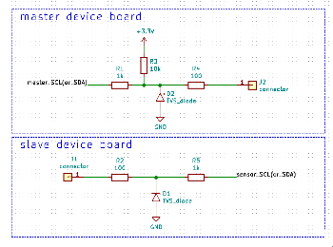

Small discussion with Jeroen:

* Is a sense resistor special -> figure this out.
* Maybe 5 1ohm resistors work -> try this to find out if this is something to continue.
* Get current h-bridge working or search for alternative (make your own h-bridge with fets maybe, higher currents?)
* Try to fix the power circuit for gaining knowledge.
* 1 small value cap for low frequency, 1 larger nf cap for higher frequencies.
* Drv8838 keeps turning somehow after disabling it.

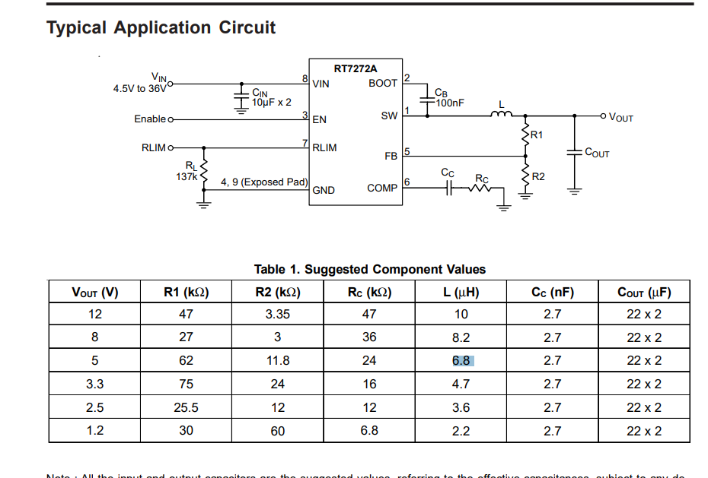

Conclusions process:

* Don’t reflow large capacitors, do it by hand after the small parts have been soldered.
* 230 degrees Celsius is usually hot enough to melt the solder paste.
* Stencils for small footprints diy soldering, otherwise solder connections will fail.
* Always three dubbel check the most important things (footprints).
* Do some life testing so create mockups for pcb’s to test fit.
* Check solder connections! Visual inspection! Mosfet that is not soldered all the way, does not work.
* Don’t unplug things, plug things or measure things while the system is powered.

# POWER usage

|  |  |  |
| --- | --- | --- |
| Component type | Name | Current (A) usage tot. |
| LED | Microscope led | 0.077 |
| FAN | Cooling FAN | 0.150 |
| HEATER | Power Resistor (10w) | 1.180 |
| Cooler/heater | Peltier | ? 0-3.6 |
| PGPIO | X | 0-6 |
| PGPIO | X | 0-6 |
| Stepper motor (small) | Focus steppermotors | 0.5 (3 motors) |
| Stepper motor (large) | Primary steppermotor | 1.7 |
| Stepper motor (medium) | Secondary steppermotor | 1.5 |
|  |  |  |